Kubernetes Task -01

- Setup Minikube on your local machine.
To install Minikube on a Mac, the most efficient and recommended approach is using Homebrew alongside Docker Desktop as your container driver.

Hardware Prerequisites
Ensure your Mac meets these minimum resource configurations before proceeding
At least 2 CPUs.
At least 2 GB of RAM.
At least 20 GB of disk space

Step 1: Install a Container Driver
Minikube needs a virtualization or container environment to deploy its cluster. Docker is the most stable and universally compatible choice for both Apple Silicon (M1/M2/M3/M4) and Intel Macs.
- Download and install Docker Desktop.
- Open Docker Desktop and follow the on-screen prompts to complete setup.
- Make sure the Docker engine is completely booted up and running.
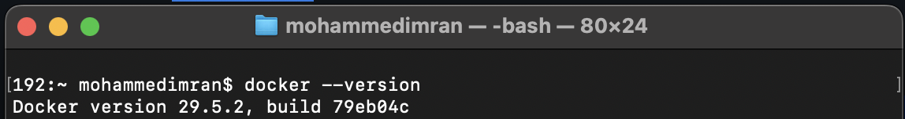

Step 2: Install Minikube and kubectl
Open your Terminal app and execute the following Homebrew command to download the packages:

brew install minikube kubectl
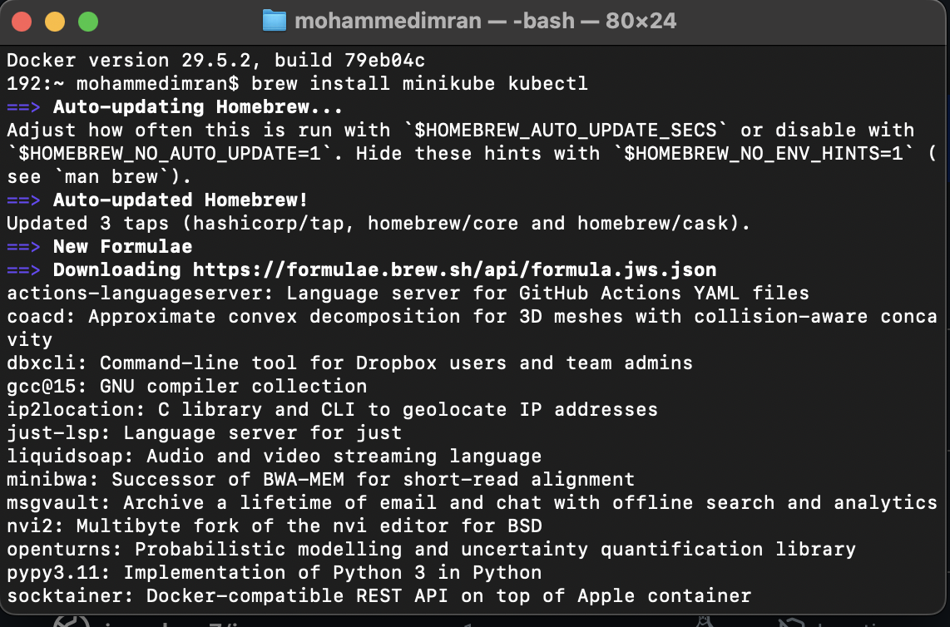
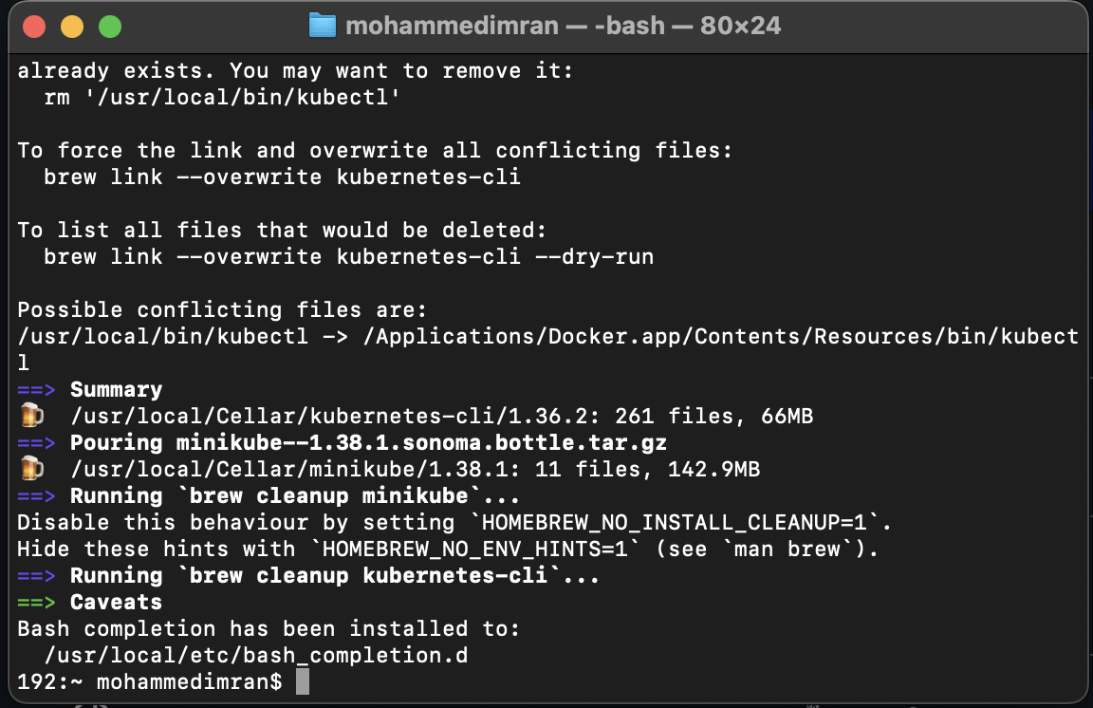

Alternative: Direct Binary Installation
If you prefer not to use Homebrew, fetch the standalone binary matching your Mac's CPU architecture
curl -LO https://storage.googleapis.com/minikube/releases/latest/minikube-darwin-amd64
sudo install minikube-darwin-amd64 /usr/local/bin/minikube

Step 3: Start and Verify Your Cluster [1]
1. Launch the cluster
Start the environment by telling Minikube to use Docker explicitly

minikube start --driver=docker
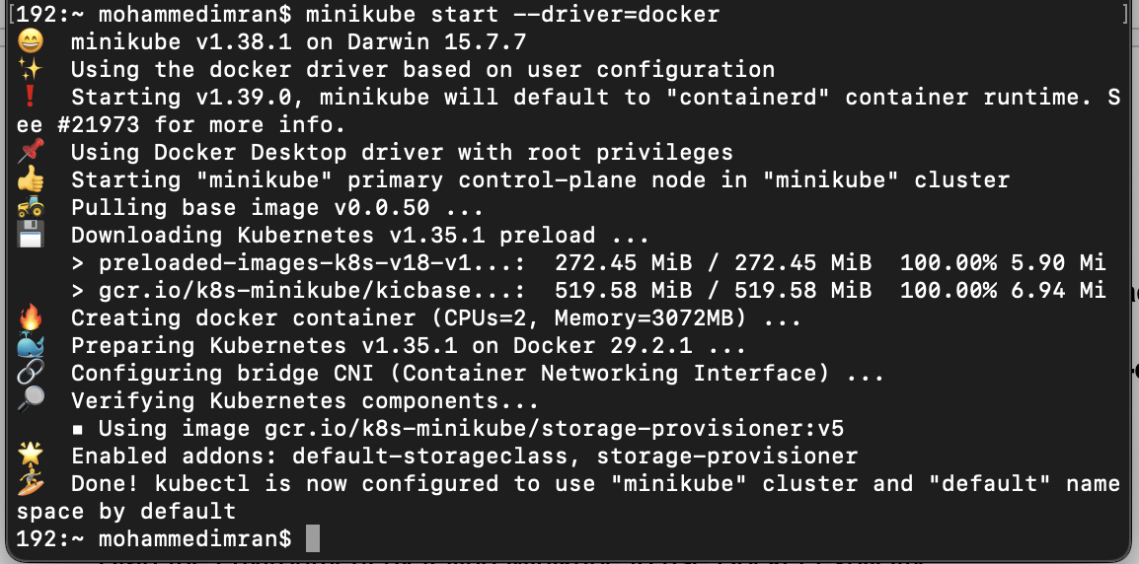

2. Check the status
Confirm that your local control plane is functional and running

minikube status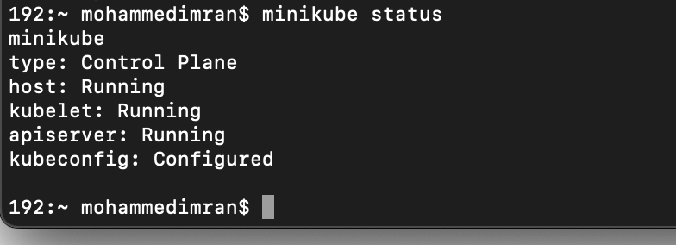
3. Test Kubernetes context
Verify that your local node is ready to accept workloads

kubectl get nodes
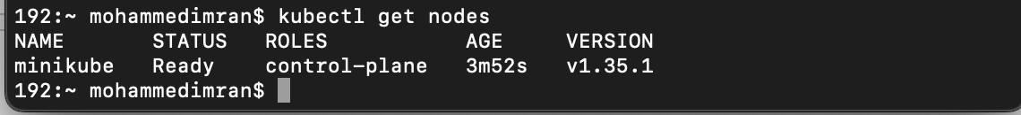

Step 4: Management Commands
Keep these brief operations handy for managing your active workspace resource footprints:
- Pause operations: minikube pause (Halts execution without erasing deployment states).
- Stop the cluster: minikube stop (Shuts down the virtual machine or container safely).
- Delete everything: minikube delete (Completely purges the cluster instance to clear disk space).
- Access Dashboard: minikube dashboard (Web management UI for real-time visualization).

- Setup k8s master and two worker nodes on ubuntu.
Lets create 3 instance one for master and two for worker nodes
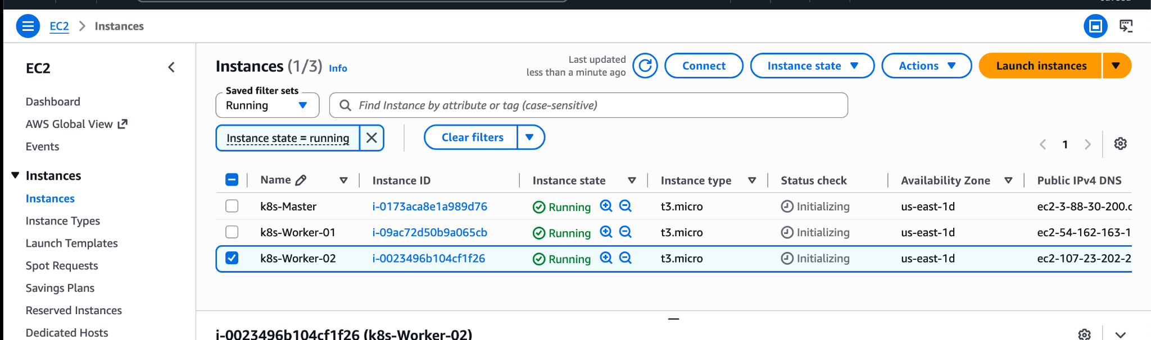
On ALL 3 machines
Master⇒worker -01⇒worker -02 Install docker
apt-get update -y
apt-get install docker.io -y
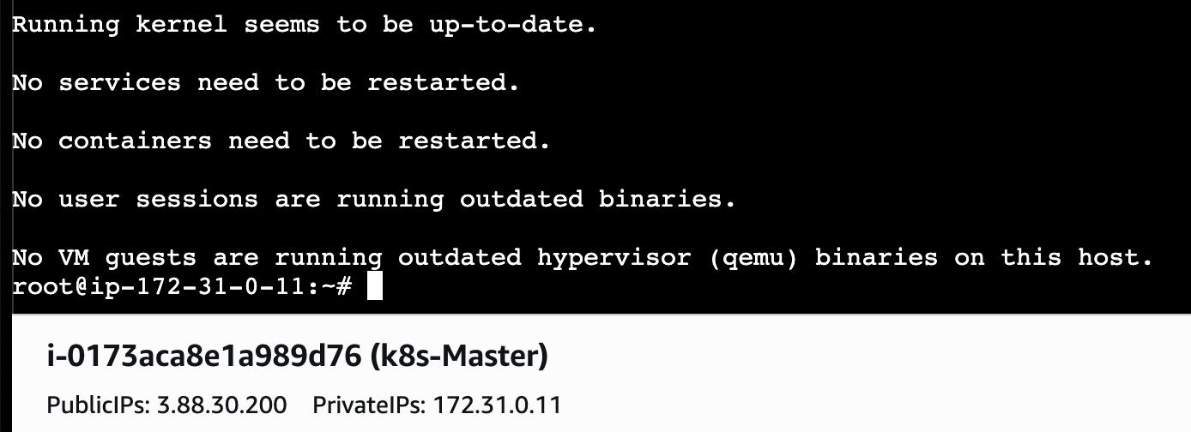
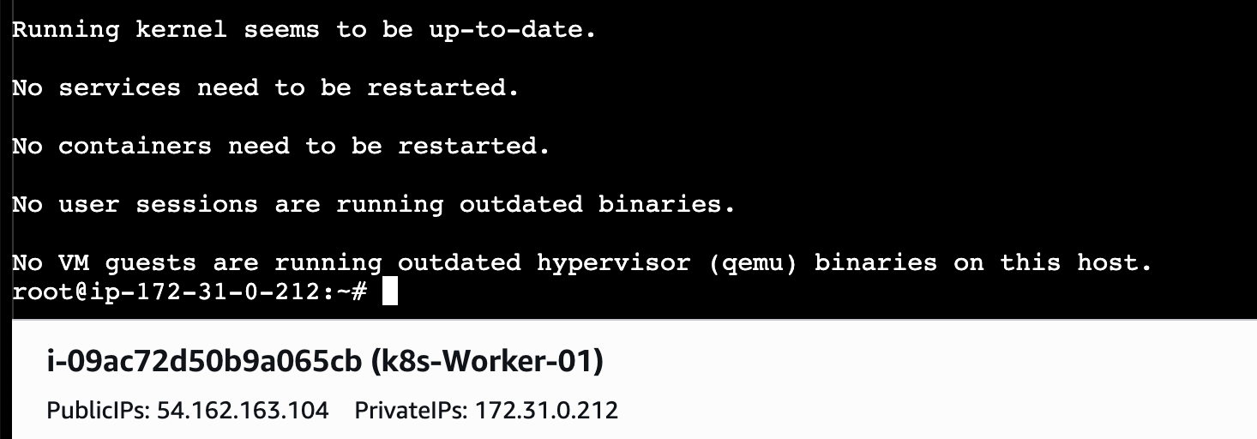
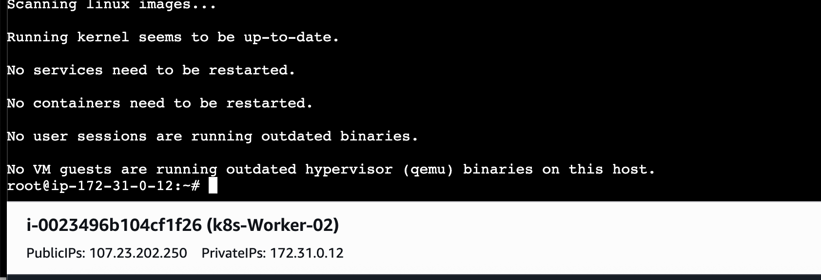
Now lets start docker on 3- MACHINES
Systemctl start docker and systemctl enable docker ⇒ for running it in background even if its stopped

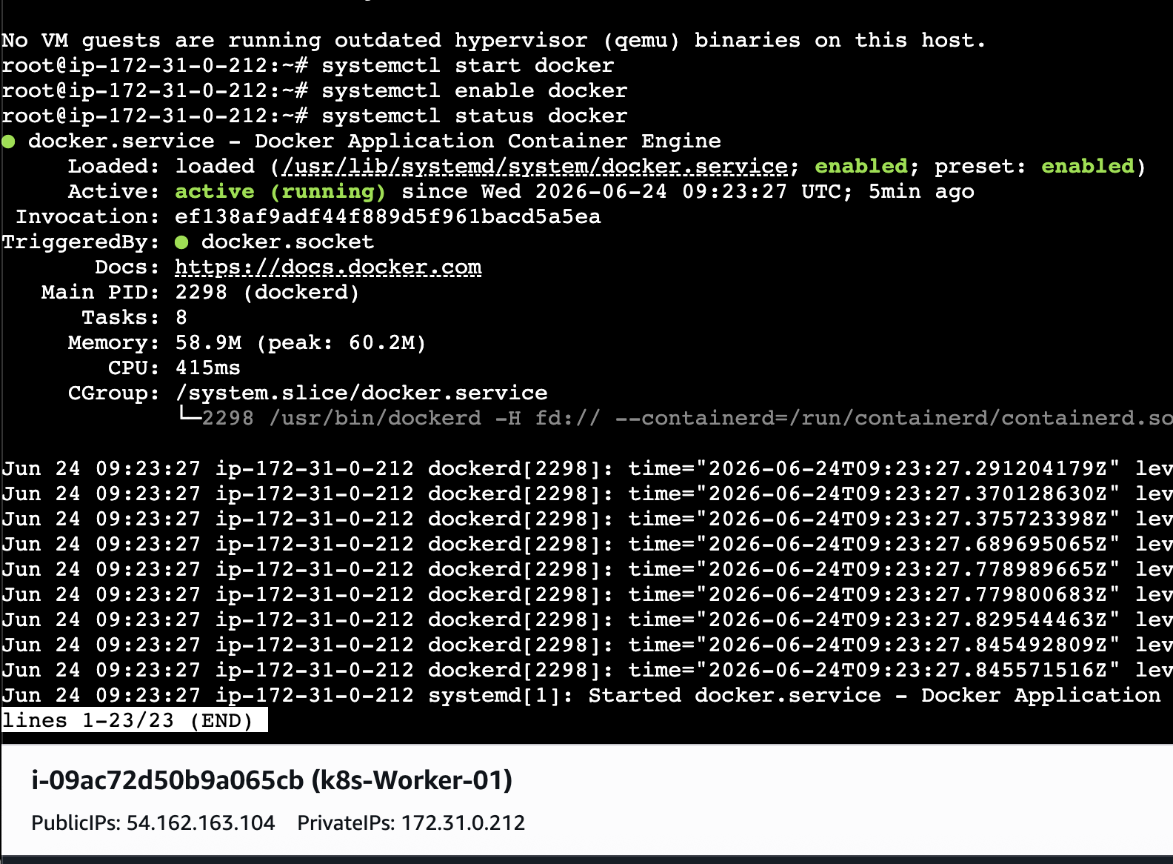
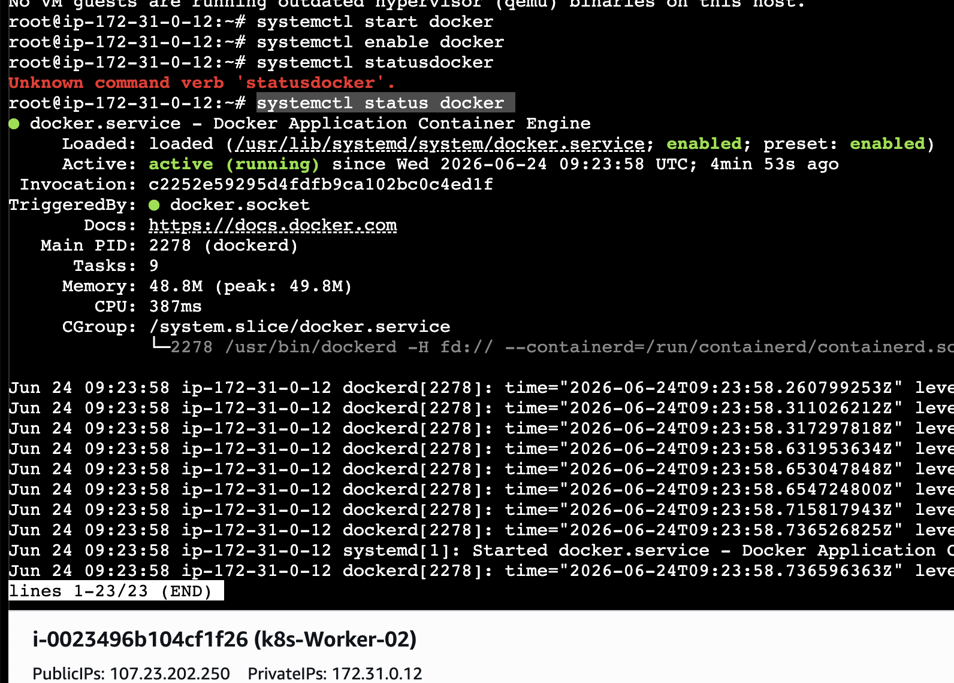
If systemctl status docker not working we can use systemctl is-active docker or docker –version
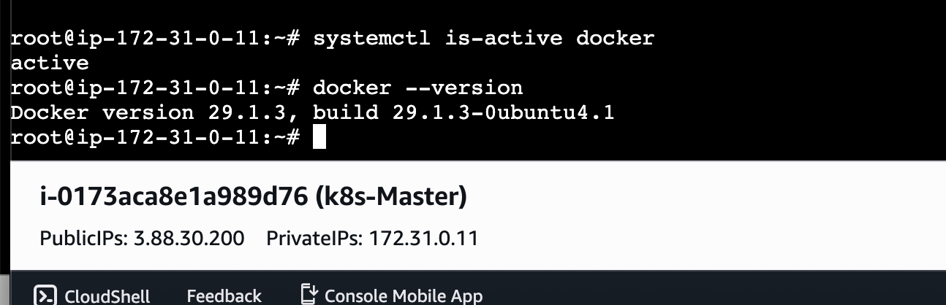

Installing kubeadm, kubelet and kubectl
We will be install these packages on all of your machines:
kubeadm: the command to bootstrap the cluster.
kubelet: the component that runs on all of the machines in your cluster and does things like starting pods and containers.
kubectl: the command line util to talk to your cluster.
kubeadm will not install or manage kubelet or kubectl for you, so you will need to ensure they match the version of the Kubernetes control plane you want kubeadm to install for you. If you do not, there is a risk of a version skew occurring that can lead to unexpected, buggy behaviour. However, one minor version skew between the kubelet and the control plane is supported, but the kubelet version may never exceed the API server version.
For example, the kubelet running 1.7.0 should be fully compatible with a 1.8.0 API server, but not vice versa.
- Update the apt package index and install packages needed to use the Kubernetes apt repository:
sudo apt-get update
# apt-transport-https may be a dummy package; if so, you can skip that package
sudo apt-get install -y apt-transport-https ca-certificates curl gpg

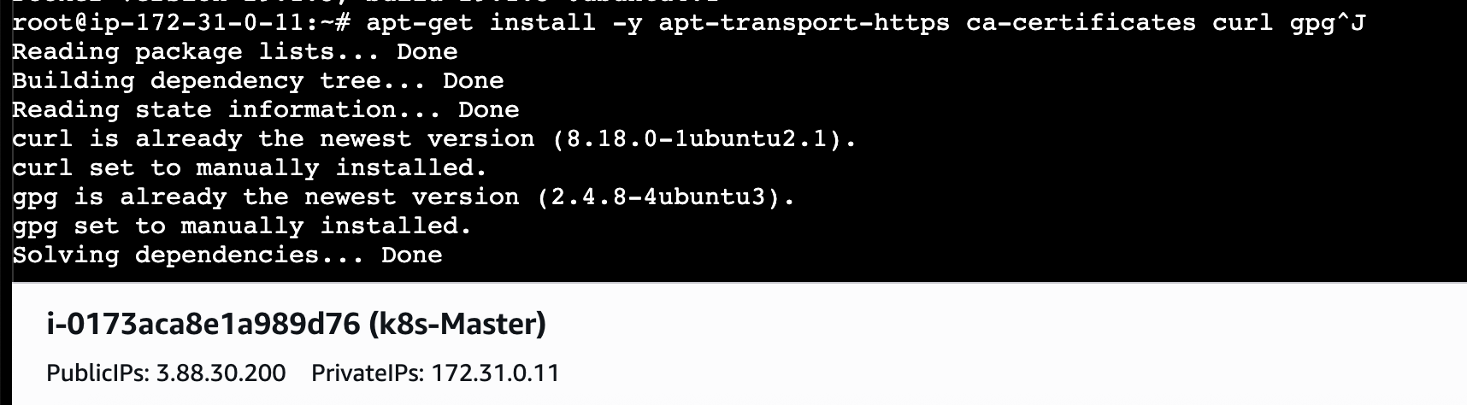
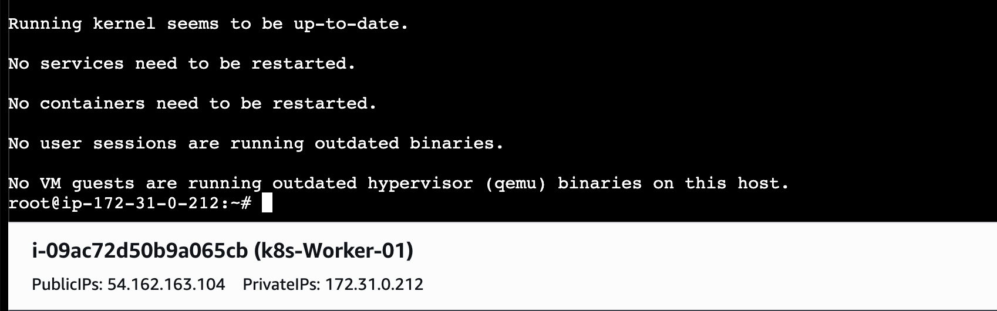

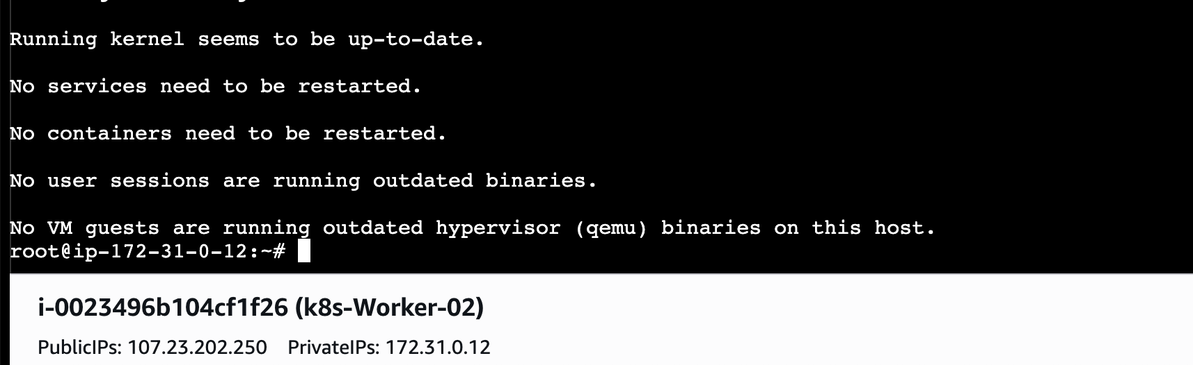

Download the public signing key for the Kubernetes package repositories. The same signing key is used for all repositories so you can disregard the version in the URL:
# If the directory `/etc/apt/keyrings` does not exist, it should be created before the curl command, read the note below.
# sudo mkdir -p -m 755 /etc/apt/keyrings
curl -fsSL https://pkgs.k8s.io/core:/stable:/v1.36/deb/Release.key | sudo gpg --dearmor -o /etc/apt/keyrings/kubernetes-apt-keyring.gpg
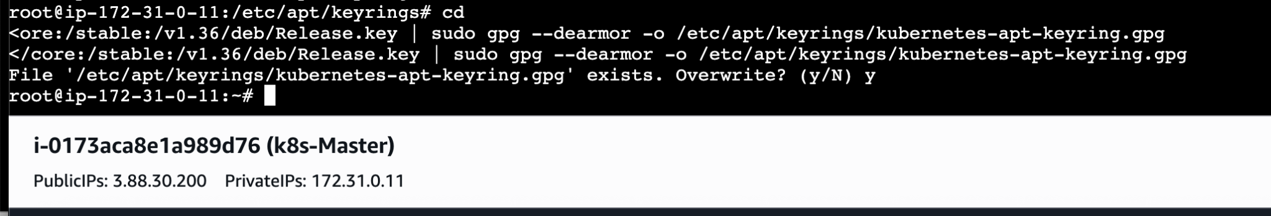
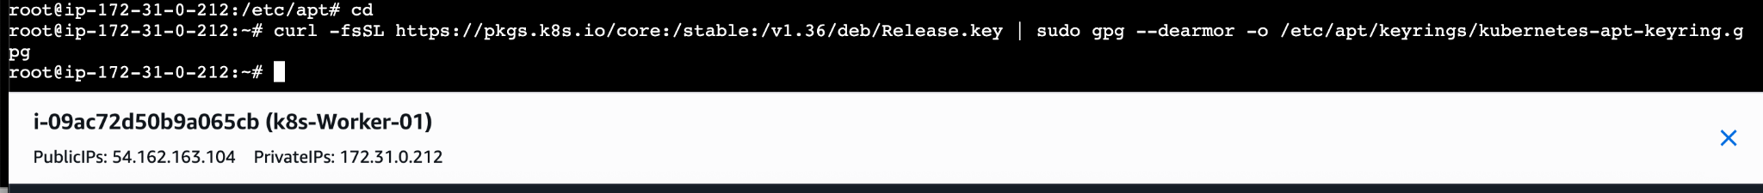
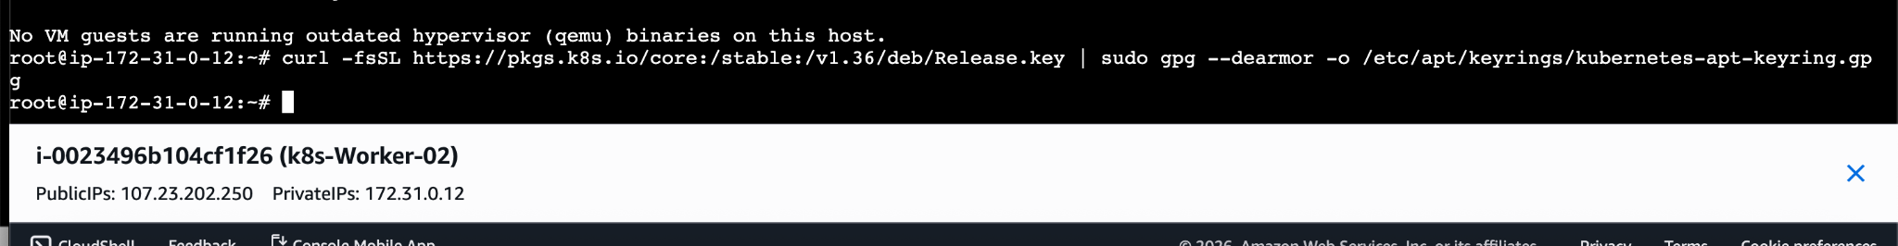
Add the appropriate Kubernetes apt repository. Please note that this repository have packages only for Kubernetes 1.36; for other Kubernetes minor versions, you need to change the Kubernetes minor version in the URL to match your desired minor version (you should also check that you are reading the documentation for the version of Kubernetes that you plan to install).

# This overwrites any existing configuration in /etc/apt/sources.list.d/kubernetes.list

echo 'deb [signed-by=/etc/apt/keyrings/kubernetes-apt-keyring.gpg] https://pkgs.k8s.io/core:/stable:/v1.36/deb/ /' | sudo tee /etc/apt/sources.list.d/kubernetes.list
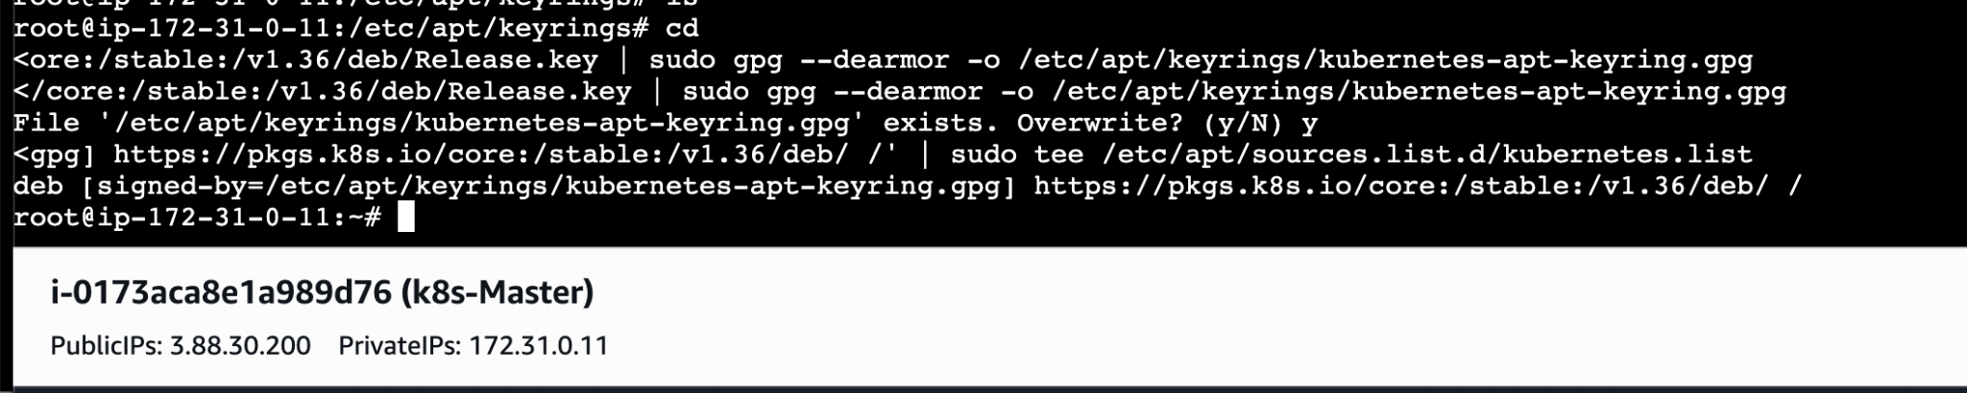
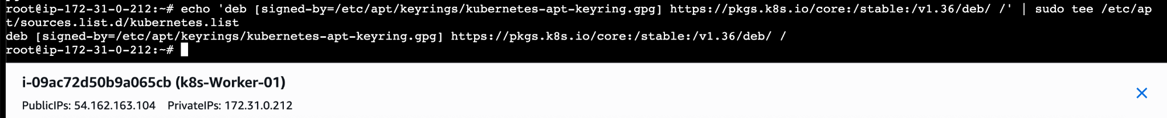
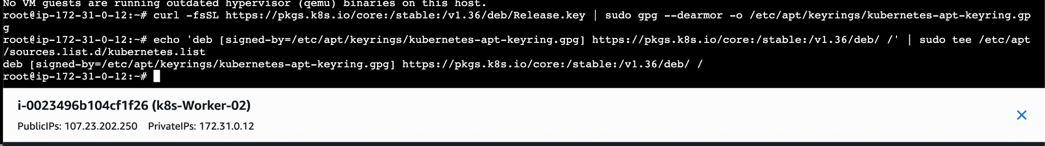
Update the apt package index, install kubelet, kubeadm and kubectl, and pin their version:
Install all the commands at once ⇒ sudo apt-get update
sudo apt-get install -y kubelet kubeadm kubectl
sudo apt-mark hold kubelet kubeadm kubectl
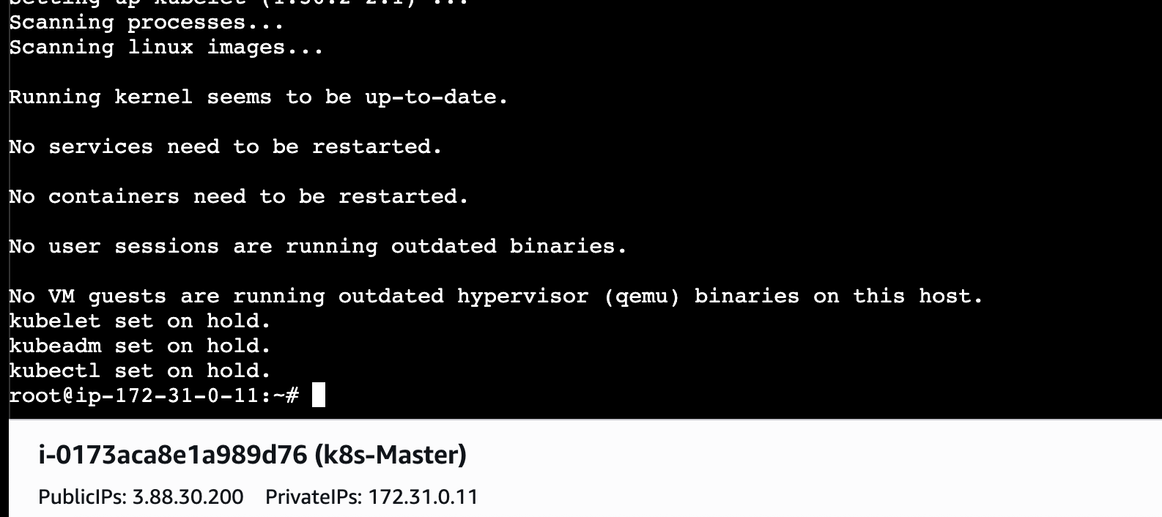
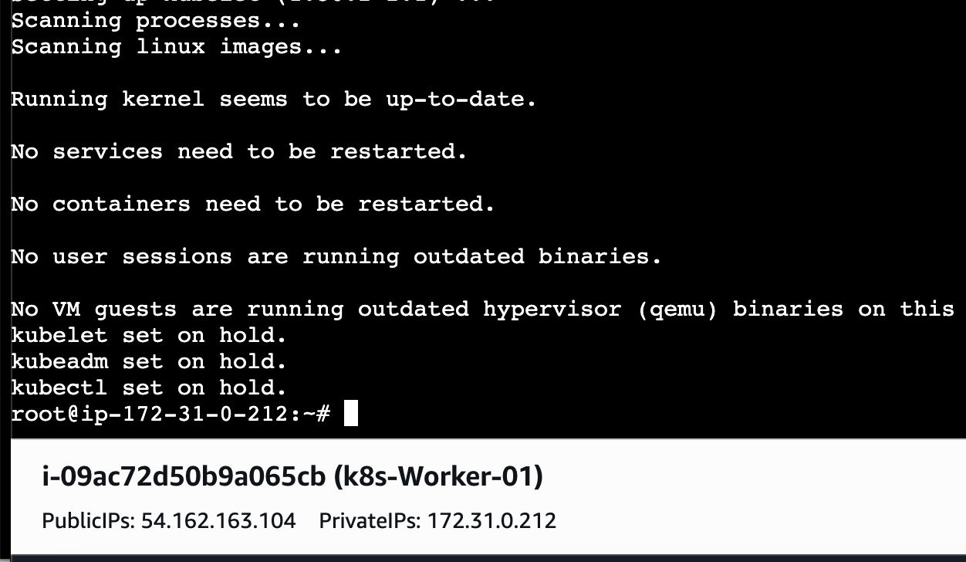
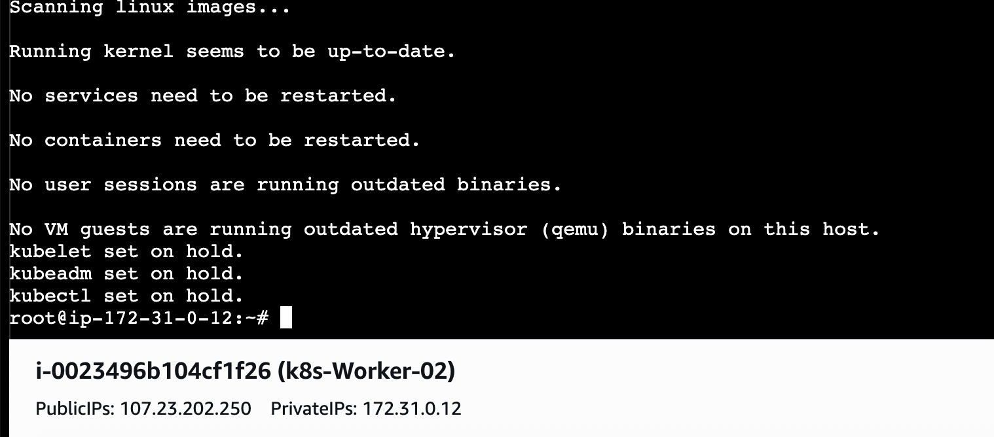
Enable the kubelet service before running kubeadm:
sudo systemctl enable --now kubelet
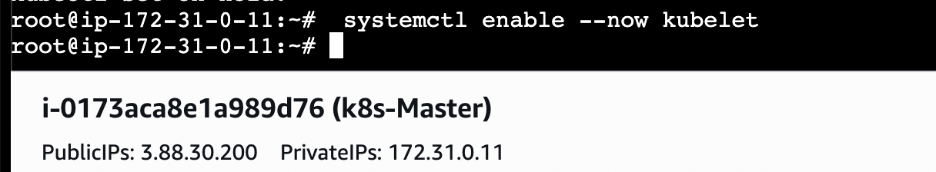
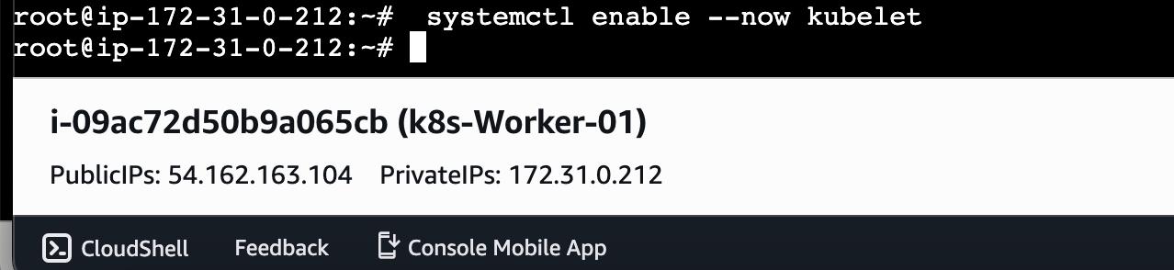
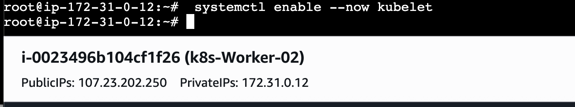
TO configure MASTER we need to initialize with CIDR
kubeadm init --pod-network-cidr=10.244.0.0/16
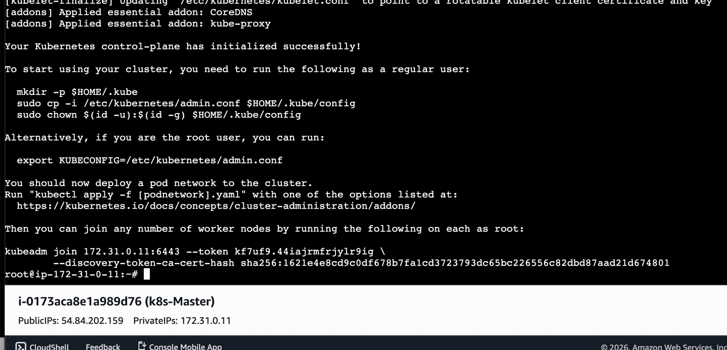
Once Network configuration is done on the MASTER node we will be asked to create a directory for storing the credentials which can be observed in the above pic.
mkdir -p $HOME/.kube
sudo cp -i /etc/kubernetes/admin.conf $HOME/.kube/config
sudo chown $(id -u):$(id -g) $HOME/.kube/config
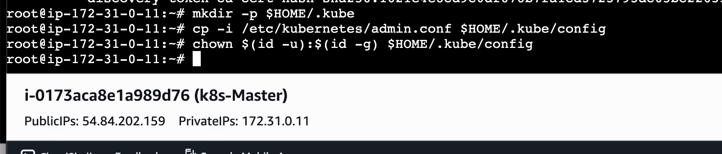
So after this we need to use command
kubeadm join 172.31.0.11:6443 --token kf7uf9.44iajrmfrjylr9ig --discovery-token-ca-cert-hash sha256:1621e4e8cd9c0df678b7fa1cd3723793dc65bc226556c82dbd87aad21d674801
This command allows all the worker nodes to connect with the master node.
To check how many worker nodes are connected to our MASTER we cuse command
Kubectl get nodes
We can see in the below pic no worker nodes are connected. By using the above kubeadm command we can connect so lets connect and see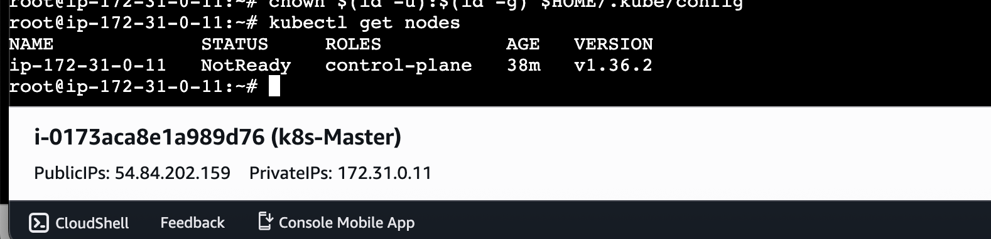

After using the kubeadm command
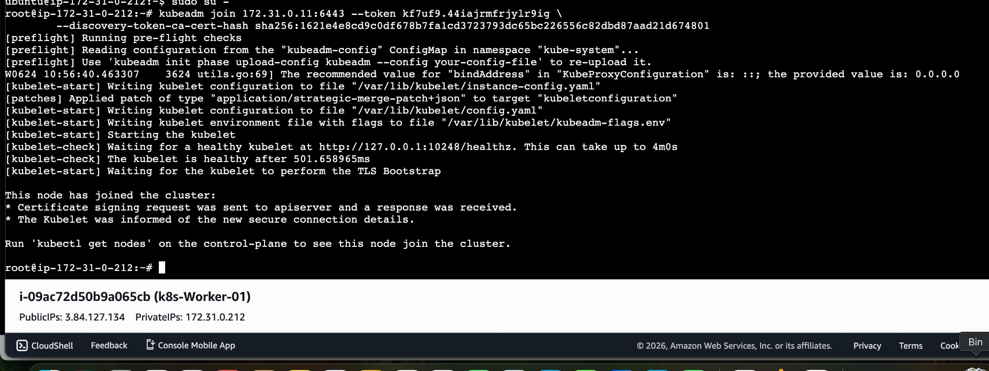
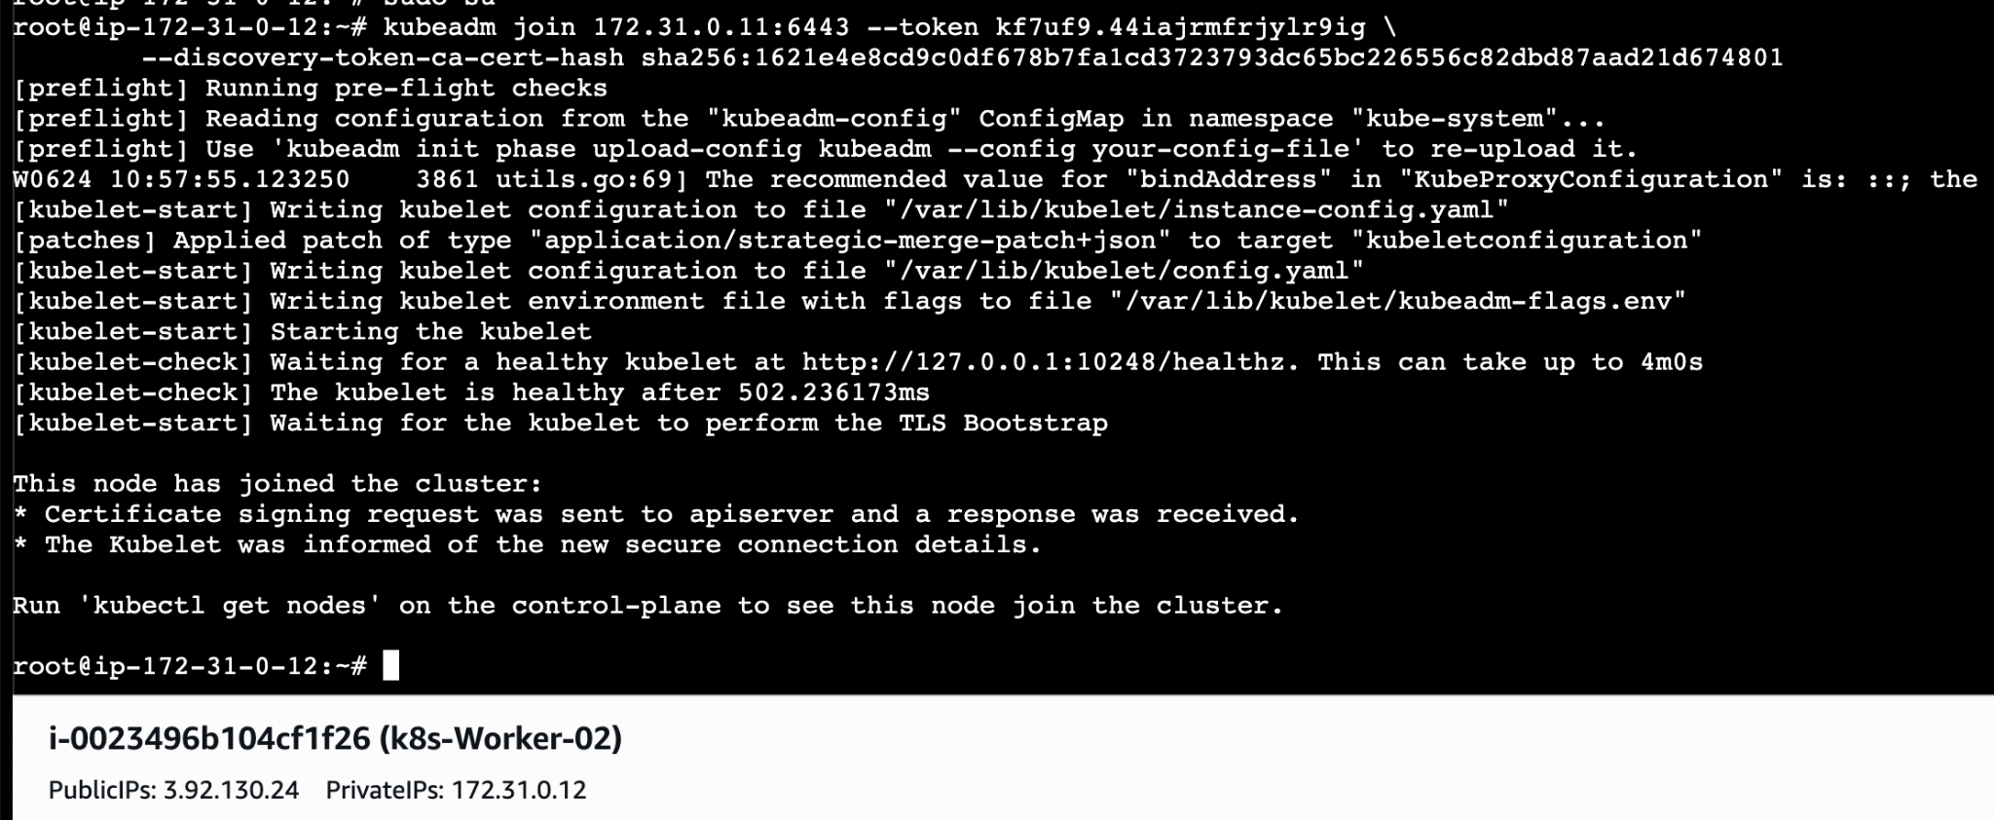
Now lets check if any worker nodes are connected using command
kubectl get nodes
We can see our worker nodes are connected to master now
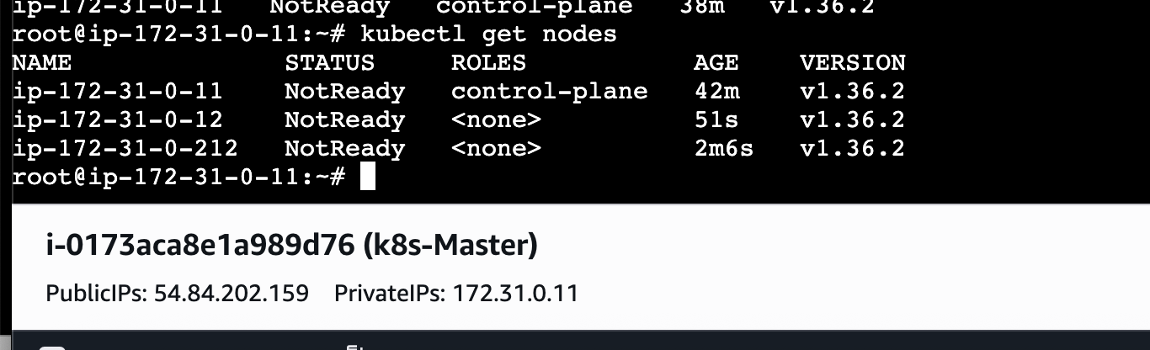
If we execute kubectl get nodes we can see the status as not ready because we haven't installed flannel
Install Flannel and check the status of nodes
kubectl apply -f https://github.com/flannel-io/flannel/releases/latest/download/kube-flannel.yml
This should be run on Masters Node
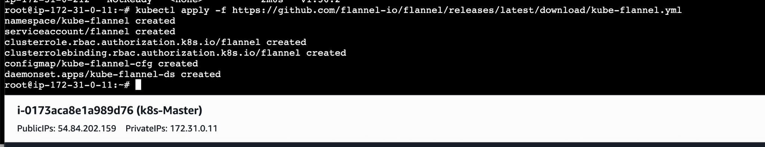
Lets check kubectl get nodes
Now we can see the nodes are ready
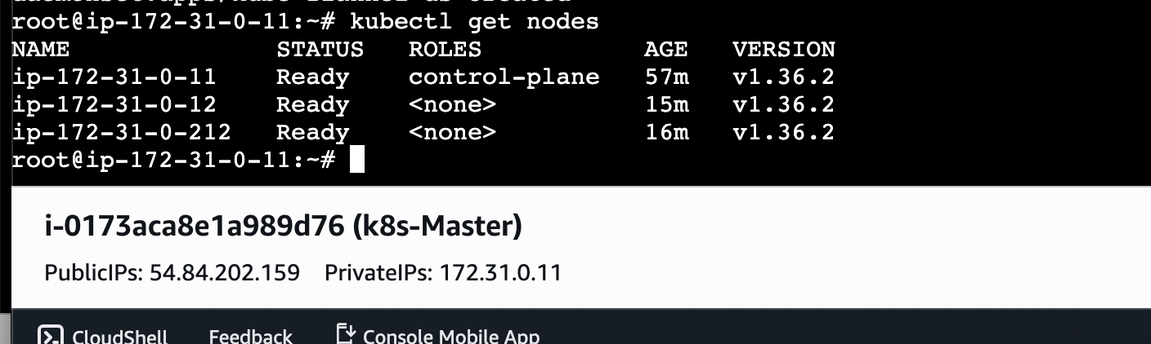
- Run one nginx pod.
A pod is the smallest deployable unit in Kubernetes. To run one Nginx pod, use
kubectl run nginx-pod --image=nginx or create a Pod YAML manifest and apply it.
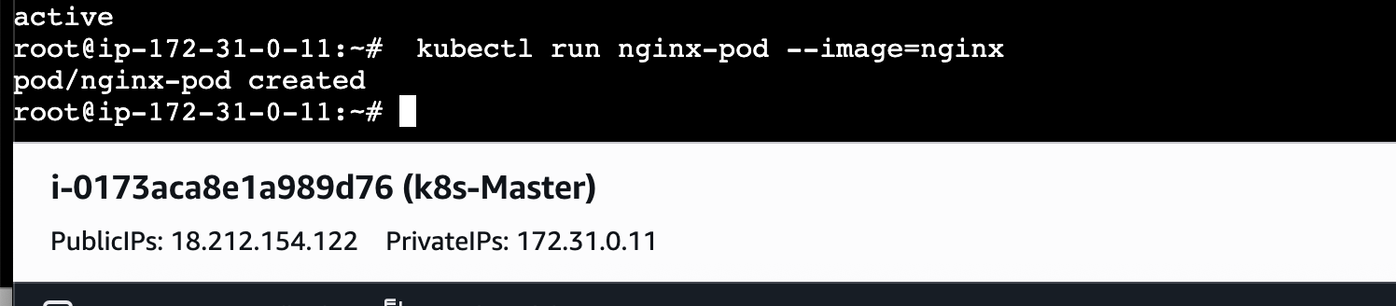
Then check your nginx pod:
kubectl get pods
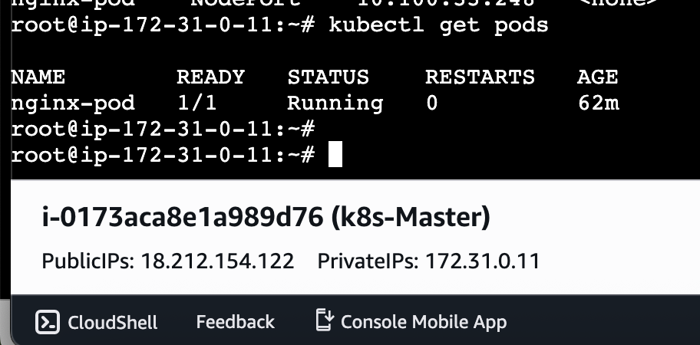

By using kubectl get pods -o wide we can know on which worker node nginx is running
Now lets expose it to port 80 using command
kubectl expose pod nginx-pod --type=NodePort --port=80
For checking the port
Kubectl get svc
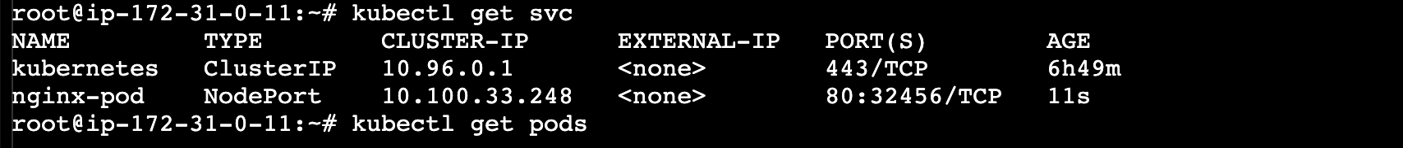
Lets check in browser
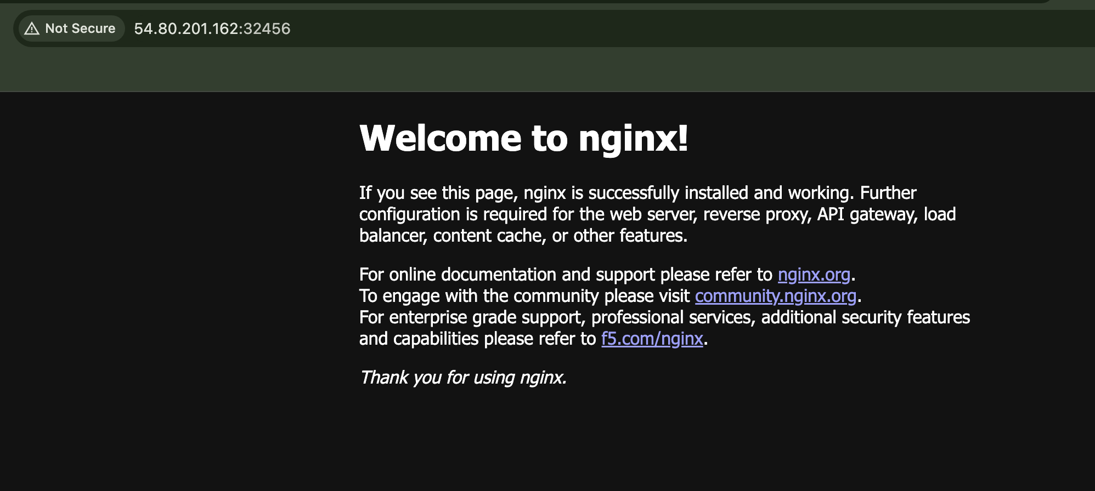

ERROR DOCUMENT

1. Pod stuck in Pending

Error
nginx-pod 0/1 Pending

Meaning
Pod was created, but Kubernetes scheduler could not place it on any node.

Root Cause
Initially, scheduling failed because nodes had taints / cluster networking was not ready.
From events:
FailedScheduling:
0/3 nodes are available: 3 node(s) had untolerated taint(s)

Solution
Waited until worker nodes joined correctly and scheduler assigned pod.
After fix:
Successfully assigned default/nginx-pod to ip-172-31-0-12

2. Pod stuck in ContainerCreating

Error
nginx-pod 0/1 ContainerCreating

Meaning
Scheduler placed the pod on a worker node, but container could not start.

Root Cause
Pod network setup failed.
From pod events:
FailedCreatePodSandBox
plugin type="flannel" failed

Solution
Investigated Flannel CNI.

3. Flannel CNI failure

Error
failed to load flannel subnet.env
open /run/flannel/subnet.env: no such file or directory

Meaning
Flannel could not configure pod networking.

Root Cause
Flannel pods were crashing.
Check:
kubectl get pods -A | grep flannel
Output:
CrashLoopBackOff

4. Flannel pods in CrashLoopBackOff

Error
kube-flannel-ds-xxxx 0/1 CrashLoopBackOff

Meaning
Flannel containers repeatedly crashed.

Root Cause
Needed logs to find exact failure.
Command:
kubectl logs -n kube-flannel <pod-name>

5. Missing br_netfilter

Critical Error
Failed to check br_netfilter:
stat /proc/sys/net/bridge/bridge-nf-call-iptables:
no such file or directory

Meaning
Linux kernel networking module required by Kubernetes was missing.

Root Cause
Worker nodes didn’t have br_netfilter loaded.
This prevented:
- bridge packet filtering
- iptables rules
- pod networking

6. Fix for br_netfilter

Commands Used
On both worker nodes:
Load module:
sudo modprobe br_netfilter
Verify:
ls /proc/sys/net/bridge/
Expected:
bridge-nf-call-iptables
bridge-nf-call-ip6tables
Enable sysctl:
sudo sysctl -w net.bridge.bridge-nf-call-iptables=1
sudo sysctl -w net.bridge.bridge-nf-call-ip6tables=1
sudo sysctl -w net.ipv4.ip_forward=1
Restart kubelet:
sudo systemctl restart kubelet
Restart Flannel:
kubectl delete pod -n kube-flannel --all

7. kubectl on worker node failed

Error
The connection to the server localhost:8080 was refused

Meaning
You ran kubectl on a worker node.

Root Cause
Worker nodes don’t have kubeconfig configured.

Solution
Run Kubernetes commands only on control plane:
Control plane: 172.31.0.11
Use workers only for OS-level commands.

8. Nginx accessible in cluster but not browser

Observation
Pod running:
nginx-pod 1/1 Running
But browsers couldn’t access it.

Root Cause
No Service existed.
Check:
kubectl get svc
Output:
kubernetes ClusterIP
Only default service existed.

Solution
Expose pod:
kubectl expose pod nginx-pod --type=NodePort --port=80
Then access:
http://<EC2-Public-IP>:<NodePort>
Also allow NodePort in AWS Security Group via AWS EC2 Security Groups docs.

Final Working State

Cluster
- Control Plane → 172.31.0.11
- Worker 1 → 172.31.0.12
- Worker 2 → 172.31.0.212

Flannel
3/3 Running

Nginx
1/1 Running

Pod Placement
Nginx scheduled on:
ip-172-31-0-212

Short interview summary
Nginx pod initially stayed in Pending, then ContainerCreating because Flannel CNI was crashing. The root cause was missing Linux kernel module br_netfilter on worker nodes. After loading the module, enabling sysctl networking parameters, restarting kubelet, and recreating Flannel pods, pod networking became healthy and the Nginx pod reached Running state. Browser access still required exposing the pod via a Kubernetes Service.

